
A14
Sreenidhi Institute of Science and Technology
(An Autonomous Institution)
Code No: 4A304
B. TECH. II-Year I-Semester Examinations, December 2015 (Regular)
CIRCUITS & NETWORKS – II (EEE)

Time: 3 Hours Max. Marks: 70

Note: No additional answer sheets will be provided.

Part - A
Max.Marks:20

Answer all QUESTIONS. EACH QUESTION CARRIES 2 MARKS.
- What are the advantages of a three phase system?
- What is the significance of initial conditions in basic circuit elements?
- Explain the physical significance of complex frequency.
- Explain about Two-port Network parameters.
- Define cut-off frequency of a filter.
- What are different forms of trigonometric Fourier series?
- What is the effect of power factor on wattmeter readings?
- What are the necessity conditions for driving point functions?
- What are desirable characteristics of ideal filter?
- Express z-parameters interms of y-parameters.

Part – B
Max.Marks:50

ANSWER ANY FIVE QUESTIONS. EACH QUESTION CARRIES 10 MARKS.
- a) Two wattmeter is used to measure power in a 3-phase balanced load. Find the power factor if the two readings are equal and have opposite sign.
b) The inductive coils each having resistance of 16 Ohms and reactance of 12 ohm are connected in star across a 400 V, Three-phase 50 Hz supply. Calculate:
i) Line voltage and phase voltage
ii) phase current and line current
Iii) Power factor
iv) power absorbed.

- a) In the network shown in Fig. the switch ‘k’ is closed at t=0, with the capacitor unchanged. Find the value for I, di/dt, d²i/dt² at t = 0⁺, for element values as follows, V=100 V, R=1000 Ω, and C= 1 µF.
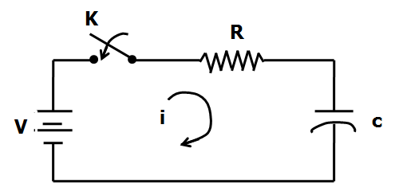
b) Derive the expression for transient response of series R-C circuit driven by sinusoidal excitation.

- a) Explain time domain behavior of network function from pole-zero plot with an example.
b) Find the transform impedance of the given time domain network of series RLC network with R = 5 Ω, L = 2 H and L = 1F.

- a) Determine the ABCD parameters of the network shown in figure
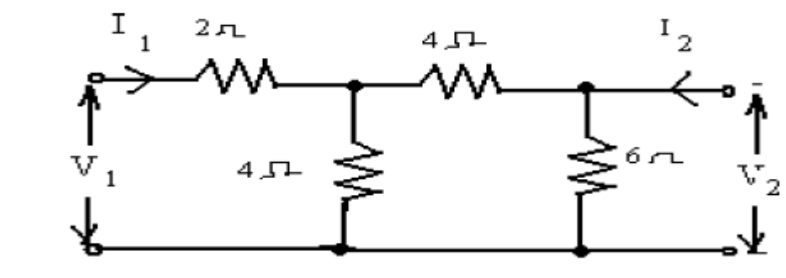
b) The Z-parameters of a two port network are Z₁₁=15, Z₂₂=24, Z₁₂=Z₂₁=6.
Determine i). ABCD parameters ii).Equivalent T network

- a) Design a low pass filter (T-network) having a cut off frequency of 2 kHz and nominal characteristic impedance of 500Ω.
b) Design m-derived T and π sections low pass filters for nominal characteristic impedance R =600 Ω, cutoff frequency= 1800 Hz and infinite attenuation frequency is 2 kHz.

- a) What is Fourier transform? Explain any three properties of Fourier transforms.
b) Find the exponential Fourier series of the given waveform.
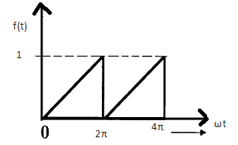

- a) A series R-L circuit with initial current I_{o} in the inductor is connected to d.c voltage Vat t = 0. Derive the expression for the instantaneous current through the inductor for t > 0.
b) The transform of current is 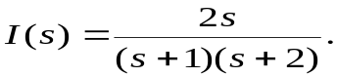 sketch its pole-zero plot and obtain time domain response i(t).

- a) Derive the condition for Z-parameters of a two port network.
b) Find the Fourier transform of the function 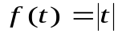 for all t.
-- 00 -- 00 --

